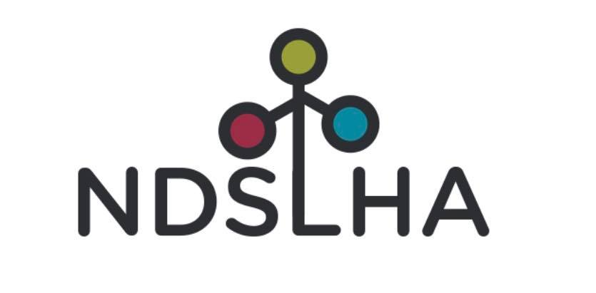

2025 NDSLHA Conference
March 28, 2025
Sleep Inn & Suites of Minot, ND

The 2025 NDSLHA conference will be held on March 28, 2025 at the Sleep Inn in Minot, ND. Graduate credit and continuing education hours will be available (graduate credit offered for those who also attend the NSSLHA conference on 3/27/2025). The conference will be in-person.

Registration and Welcome (7:00 AM - 8:00 AM)
Attendees sign in, receive materials, and prepare for the day.

Morning Breakout Sessions (8:00 AM - 9:30 AM)
Audiology Track – Interdisciplinary Insights
  - Session 1 8:00 – 8:40 AM: Spotting the Signs: When Audiologists Should Refer for Skin Cancer Concerns
    - Presenter: Anne Welch, FNP
    - Location: Sunshine Room
  - Session 2 8:50 – 9:30 AM: See the Big Picture: Otoscopy Essentials for Audiologists
    - Presenter: Alycia Coutts, FNP
    - Location: Sunshine Room
SLP Track
- SLP Keynote 8:00-9:30: Navigating Assessments for Children with Complex Communication Needs: Comprehensive Strategies and Tools
  - Presenter: Dr. Katrina Fulcher-Rood, CCC-SLP, BCS-CL, The Big Picture SLP
  - Location: Convention Center
Morning Coffee Break & Exhibitor Hall (9:30 AM - 10:00 AM)
Network with colleagues, grab refreshments, and explore products and services offered by exhibitors.
Audiology Track – Industry Update
  - Session 3 9:45 – 10:00 AM: A Stepy-by-Step Guide to eSRT Protocol Set Up
    - Presenter: Matt Williams
    - Location: Sunshine Room

Morning Breakout Sessions (10:00 AM - 12:00 PM)

Audiology Track – Optimizing Outcomes and Best Practices in Cochlear Implant Care

Session 4 10:00 – 12:00 PM: Efficiencies/ Protocols/ MSTB-3/ Manufacturer Supports/ Remote Programming/ eSRTs

Presenter: Aggie Kennedy, AuD, CCC-A

Location: Sunshine Room
SLP Track
- SLP Keynote 10:00-12:00: Navigating Assessments for Children with Complex Communication Needs: Comprehensive Strategies and Tools
  - Presenter: Dr. Katrina Fulcher-Rood, CCC-SLP, BCS-CL, The Big Picture SLP
  - Location: Convention Center

Lunch, Business Meeting, Awards & Headshot Booth (12:00 PM - 1:00 PM)
Lunch provided, followed by the association’s annual business meeting and professional honors/awards.
Enhance your professional image with an updated headshot sponsored by Gemar Photography! Visit the headshot booth to capture a polished and professional photo that showcases your expertise and confidence.

Audiology Track – Optimizing Outcomes and Best Practices in Cochlear Implant Care
- Session 5 12:30 – 1:00 PM: Updates from Cochlear and eSRT Tips for Pediatrics
  - Presenters: Sarah Almquist, AuD and Jesi Novak, AuD, CCC-A, PASC
  - Location: Sunshine Room

Afternoon Breakout Sessions (1:00 PM – 3:00 PM)

Audiology Track – Hands-On eSRt Lab and Strategies for Aural Rehabilitation Success

Session 5, 1:00 – 2:00 PM: eSRT in Action: A Hands-On Lab for Tuning Up Your Skills!

Presenter: Aggie Kennedy, AuD, CCC-A

Location: Sunshine Room
    - Session 6, 2:00 – 3:00 PM: From Baby Steps to Golden Years: Aural Rehab for Every Stage of Life!
      - Presenter: Gretchen Flynn, AuD
      - Location: Sunshine Room
SLP Track
- SLP Breakout 1:00-3:00: Practical Applications in Assessment and Intervention for Culturally and Linguistically Diverse (CLD) Populations
  - Presenter: Dr. Katrina Fulcher-Rood, CCC-SLP, BCS-CL, The Big Picture SLP
  - Location: Convention Center
- SLP Breakout 1:00-3:00: Understanding and Supporting Students with Brain Injury
  - Presenter: Sarah Ring
  - Location: Theater Room

Afternoon Coffee Break, Networking & Photo Ops (3:00 PM – 3:30 PM)
Recharge with refreshments while connecting with colleagues during an afternoon break. Photo booth will be open to make lasting memories at the conference.
Afternoon Break Out Sessions (3:30 PM – 4:30 PM)
Indigenous People – Cultural Competency and Relationship Building
- Presenter: Annette Mennem
- Location: Convention Center

Optimizing Outcomes and Best Practices in Cochlear Implant Care (this session will be applicable to SLPs)

Presenter: Aggie Kennedy, AuD, CCC-A

Location: Sunshine Room

4:30 – 4:45 PM: Closing Remarks
Summarize the key takeaways from the day, followed by the presentation of awards for outstanding contributions to the field.

