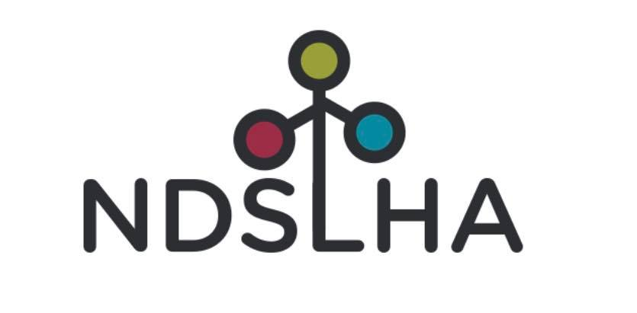

2026 Conference Registration

The 2026 NDSLHA Conference will be held in person on March 27, 2026, at the Grand Hotel in Minot, ND. Attendees will have the opportunity to earn 8 hours of continuing education. Additionally, NDSLHA is partnering with the Minot State National Student Speech-Language-Hearing Association (NSSLHA) to offer one graduate credit (15 hours) for those who attend both the NDSLHA Conference on March 27 and the NSSLHA Conference on March 26, 2026.

Group Leader Information:
Full Name: _____________________________________________________________________________
Organization/Company Name: _____________________________________________________________
Email Address: __________________________________________________________________________
Phone Number: _________________________________________________________________________
Mailing Address: ________________________________________________________________________

City, State, Zip Code: _____________________________________________________________________

How many attendees are you signing up (see page 2 for attendee information)? _______________________

Group Registration Deadline: March 6, 2026

Early Bird Registration
Postmarked/Submitted by 2/28/26
NDSLHA membership registration is included in all conference registrations!
[] Professional (SLP, Audiologist, SLPA): $100
[] Students: $20

Registration
Postmarked/Submitted after 2/28/29
NDSLHA membership registration is included in all conference registrations!
[] Professional (SLP, Audiologist, SLPA): $125
[] Students: $20

Group Agreement
By signing below, the group leader confirms the following:
- I certify that the information provided above is accurate.
- I acknowledge that group registration is subject to the conference’s policies and deadlines.
- I agree to comply with all conference rules and guidelines.

Signature of Group Leader: _______________________________________________________________
Date: __________________________________________________________________________________

Please make checks payable to: NDSLHA

Group registration forms can be emailed to ndslha@gmail.com or mailed to:
NDSLHA
PO Box 138
Bismarck, ND 58502-0138

Please fill out the name and contact information for each participant:

Attendee Name | Email | Phone Number | Dietary Restrictions

