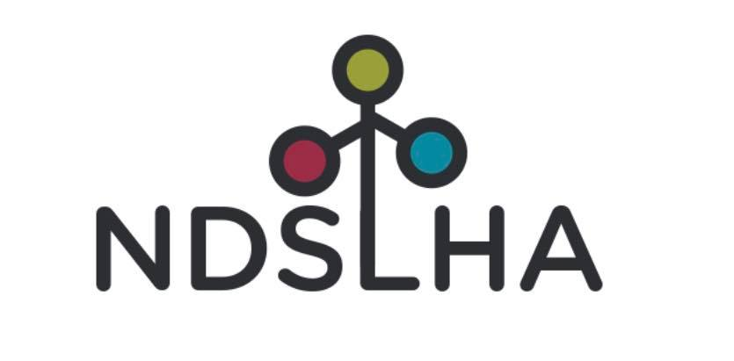

2026 North Dakota Speech Language Hearing
Association Conference
Exhibitor Registration
March 27, 2026
Grand Hotel, Minot, ND

Advertise your business to over 100 attendees, including SLPs, SLP graduate students, and Audiologists!

Attendees will be able to visit the exhibit hall at the following times:
7:30-8:00am
9:30-10:00am
12:30-1:00pm
3:00-3:30pm

The cost is $200.

Breakfast pastries, refreshments, and lunch for one person will be provided. Additional lunches can be purchased.

Register online here! Prefer to pay/register by mail? Email us at ndslha@gmail.com.
Exhibitor spots are reserved once payment is received. Spots are limited.

Additional conference information can be found here: https://www.ndslha.org/convention/

A block of rooms is reserved at the Hampton Inn & Suites Minot Airport (701-838-1400) for $110 + tax. Rooms must be reserved by 3/10/26. Book online at this link.

Please email ndslha@gmail.com with questions.

