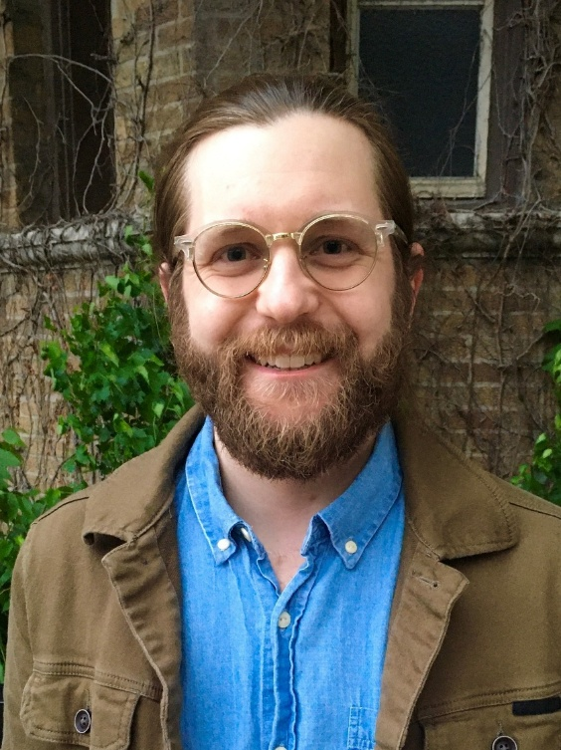
Session Title: When, Why, and How to Verify Advanced Processing Strategies
Presenter: Joseph F. Hribar, Jr., AuD
Speaker Bio: Joseph (Joey) Hribar, AuD is a research audiologist on the Global Audiology team at GN Hearing in Glenview, IL. He is responsible for conducting hearing aid testing, which
includes verifying and validating hearing instruments, accessories, and other connective devices. His interests lie in modern technology and its impact on hearing healthcare and the patient experience. He earned his Doctor of Audiology degree from The Ohio State University in
Columbus, OH.
Session Description: Electroacoustic (EA) verification and real ear measures (REM) are well-
established best practices in the field of audiology. Using a test box to verify using ANSI
standards can assess if the overall performance of a hearing aid is meeting manufacturer’s
specification, and REM testing can ensure hearing aids are providing gain that matches
prescriptive targets. However, these tests often rely on turning off advanced processing strategies or looking at the hearing aid system holistically. Verification of individual advanced processing strategies, such as microphone directionality and noise reduction, can also provide value in clinic settings. Verifying advanced processing strategies can help answer if the feature working, what the feature is doing, and how it is impacting the patient. This session will cover when, why, and how to verify directional and noise reduction processing strategies, while maintaining a patient centered approach.
Learning Objectives: Upon completion of this course, participants will be able to:
1. Assess clinical goals of verification of advanced processing strategies.
2. Recognize if a real ear or test box measurement is most appropriate to meet their verification goals.
3. Identify when and how to verify complex directionality and noise reduction schemes.
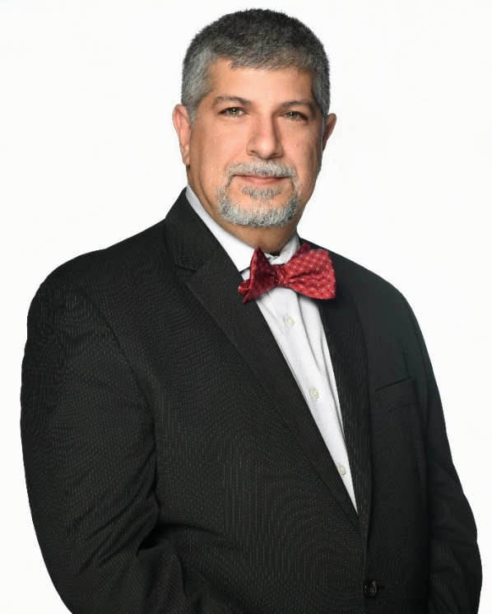

Session Title: Understanding and Supporting the Everyday Experience of Hearing Loss in Older Adults
Presenter: Navid Taghvaei, MA, Au.D., ABAC,CCC-A
Lead Clinical Education Specialist
Speaker Bio: Dr. Taghvaei is a Lead Clinical Education Specialist with WSA. He is responsible for conducting very complex individual and group technical training courses and activities
involving new and existing developments in the areas of audiology, products, software,
and technology for employees and customers. He demonstrates multi-system products by
preparing and conducting clinician training, supports clinical product offerings, and
performs in-house clinical trials for the Audiology Department team. He has extensive
clinical experience in pediatric and adult hearing instrument and cochlear implant fitting,
programming, and rehabilitation. He has served as a practicing Clinical Director of
Audiology in multiple multi-disciplinary otolaryngology and audiology clinics in the U.S.
and internationally. Navid received his doctorate in Audiology and master’s degree in
Hearing Science from the University of Louisville School of Medicine and his bachelor’s
degree in Cognitive Psychology from Arizona State University.
Session Description: Hearing loss is a common and often under-recognized condition among older adults, with far-reaching effects on physical health, emotional well-being,
communication, and social connection. This course explores the everyday, lived
experience of age-related hearing loss, highlighting its gradual progression,
psychosocial impact, and the adaptive strategies individuals use to navigate daily
life. Participants will gain a comprehensive perspective on how hearing loss
influences communication effectiveness, cognitive load, and social participation.
Emphasis is placed on patient-centered approaches that support positive aging
through education, individualized care, and the effective use of hearing aids and
assistive listening technologies. The session also reviews validated assessment
tools that help clinicians evaluate auditory function, quality of life, and patient
outcomes. Grounded in evidence-based practice, this course equips hearing care
professionals with practical insights and strategies to enhance engagement,
resilience, and overall well-being in older adults living with hearing loss.
Learning Objectives: Upon completion of this course, participants will be able to:
- Explain the concept of the lived experience of hearing loss and its relevance
to older adults.
- Identify the physical, emotional, and social domains impacted by hearing
impairment.
- Implement strategies that empower individuals to manage their hearing
health and remain socially engaged.
- Utilize comprehensive assessment tools to evaluate the broader effects of
hearing loss and guide personalized care planning.

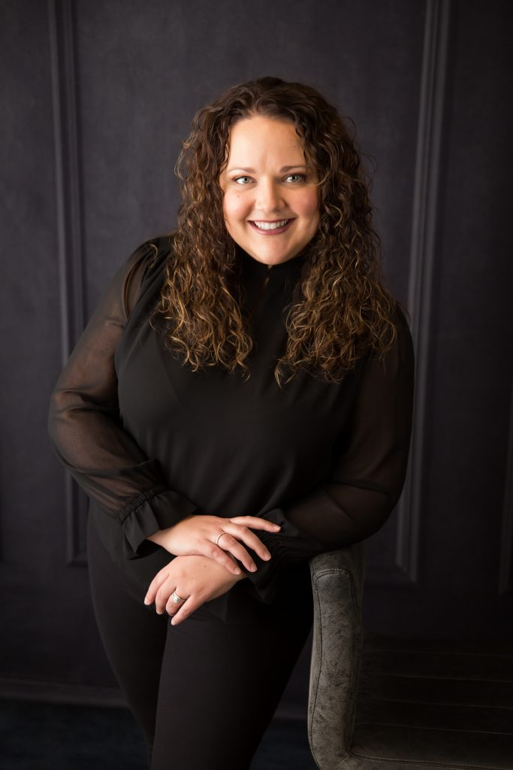

Session Title:

Presenter: Amanda Leddige, Au.D.

Speaker Bio: Dr. Amanda (Heringer) Leddige is a Bismarck native. She earned her bachelor's degree in Communication Sciences: Pre-Audiology from Minnesota State University Moorhead in 2009. She continued her education at the University of Colorado, Boulder, and graduated with her Doctorate of Audiology in 2013. She completed clinical rotations at the University of Colorado Hospital, Rocky Mountain Cochlear Implant Center, Children’s Hospital Colorado and Sanford Health. She has been providing audiological care to the Bismarck/Mandan and surrounding communities since 2013. She founded Alliance Center for Hearing in May 2021. Dr. Leddige specializes in hearing evaluations, tinnitus treatment, hearing aids, bone anchored hearing aids, cochlear implants, cerumen management, hearing conservation and hearing rehabilitation. She loves to educate and engage in community events to help spread awareness of hearing loss, prevention and treatment. Dr. Leddige has completed specialized training in the management of tinnitus and sound sensitivity disorders under Dr. Pawel Jastreboff, Ph.D., Sc.D. She is also excited to offer Lenire, the first FDA approved bimodal neuromodulation device for tinnitus treatment.

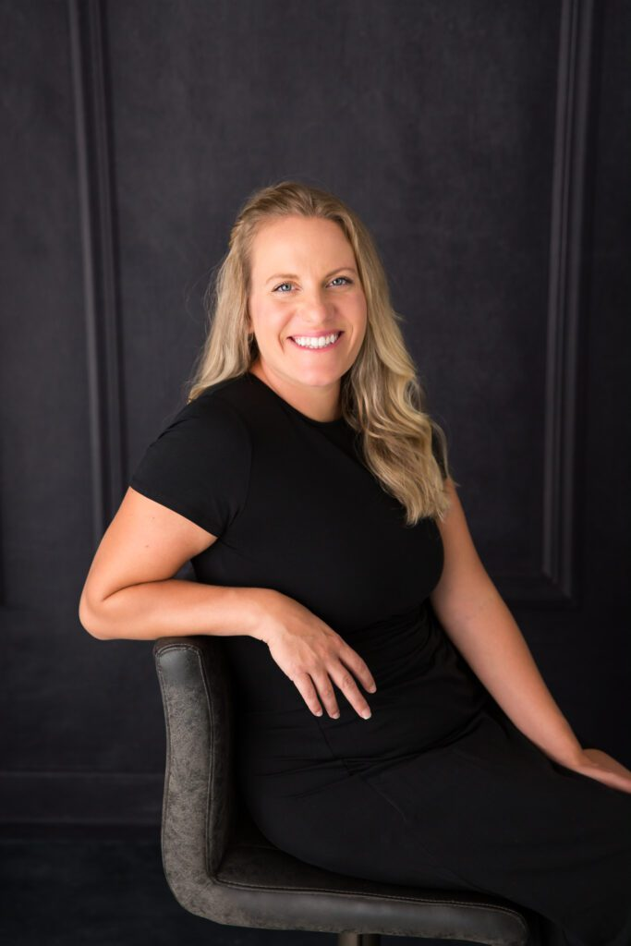

Session Title:

Presenter: Jessica McLindsay, AuD.

Speaker Bio: Dr. Jessica (Vetter) McLindsay is a Bismarck native. She earned her Bachelor’s degree in Communication Sciences: Pre-Audiology from Minnesota State University Moorhead in 2009. She continued her education at A.T. Still University in Mesa, Arizona and graduated with her Doctorate of Audiology in 2013. She completed clinical rotations at University of Minnesota Children’s Hospital along with Audiology Concepts in Minneapolis, Minnesota. Dr. McLindsay has spent her professional time in private practice audiology and ENT settings helping both children and adults with all of their hearing healthcare needs. Dr. McLindsay specializes in hearing evaluations, tinnitus treatment, hearing aids, cerumen management, hearing conservation, hearing rehabilitation and Veteran evaluations. Dr. McLindsay is also an Adjunct Professor at the University of Mary teaching both undergraduate and graduate students fundamental audiological skills. Dr. McLindsay is licensed as an audiologist and hearing instrument specialist in the state of North Dakota. She is a Fellow of the Academy of Doctors of Audiology and Associate member of the Tinnitus Practitioners Association. Dr. McLindsay has completed specialized training in the management of tinnitus and sound sensitivity disorders under Dr. Pawel Jastreboff, Ph.D., Sc.D. She is also excited to offer Lenire, the first FDA approved bimodal neuromodulation device for tinnitus treatment.

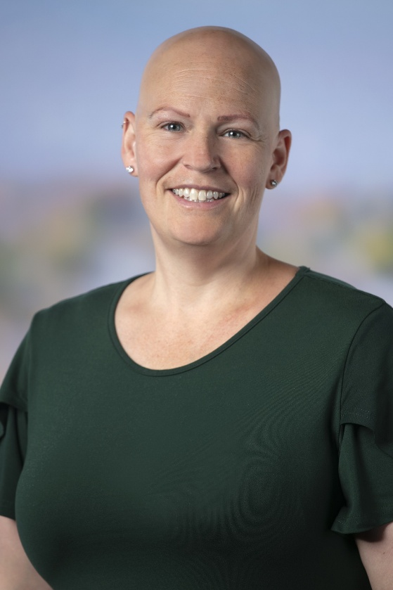
Session Title:

Presenter: Sarah Mathews, Au.D.

Speaker Bio: Dr. Sarah Mathews, Au.D., has been providing comprehensive audiology and tinnitus management services since 2002. Her professional experience spans private practice, collaborations with ENTs, and roles within the hearing aid and tinnitus device manufacturing sectors. Currently, she serves as the Clinical Training and Business Development Manager at Neuromod, the manufacturer of the Lenire device. Throughout her career, Dr. Mathews has presented and trained audiologists on hearing aids and tinnitus therapies both domestically and internationally. Clinically, she specializes in using Tinnitus Retraining Therapy (TRT), mindfulness, cognitive-behavioral techniques, sound therapy, and the Lenire device to support tinnitus patients.

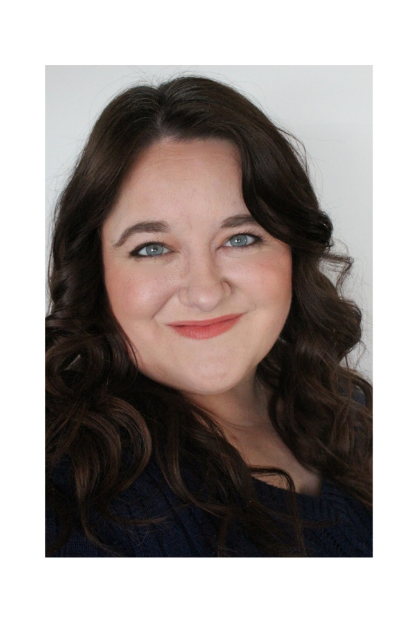
Session Title: BrainHearing™ Innovations from Oticon
Presenter: Jessica James, Au.D., CCC-A
Session Description: In this session, we will introduce Core Technologies and BrainHearing™ principles for Oticon hearing solutions. Oticon’s purpose-built platforms drive advanced technologies aiding the brain in sound comprehension and navigating complex listening scenarios. We will delve into key technologies, details, and concepts related to our unique signal processing approach.
Speaker Bio: Jessica is the Education and Training Specialist for Oticon’s MidAmerica region. She is responsible for new and continuing education programs for hearing care professionals, technical product training, and audiology field support. She spent six years at a fast-paced ENT office in Indianapolis prior to this position. In that position she performed diagnostics for all ages,
performed adult vestibular assessments, and performed fitting/follow up care for patients 12
years and older for hearing aids in multiple manufacturers. Dr. James holds a Doctor of
Audiology degree from Ball State University.
Learning Objectives: Upon completion of this course, participants will be able to:
- Participants will be able to outline situations where the modern patient has difficulty hearing and how their behavior has changed due to their impairment.
- Participants will be able to explain how technology can help patients hear better in complex listening environments.
- Participants will be able to identify how Oticon’s current core technologies are used to help patients in challenging environments.

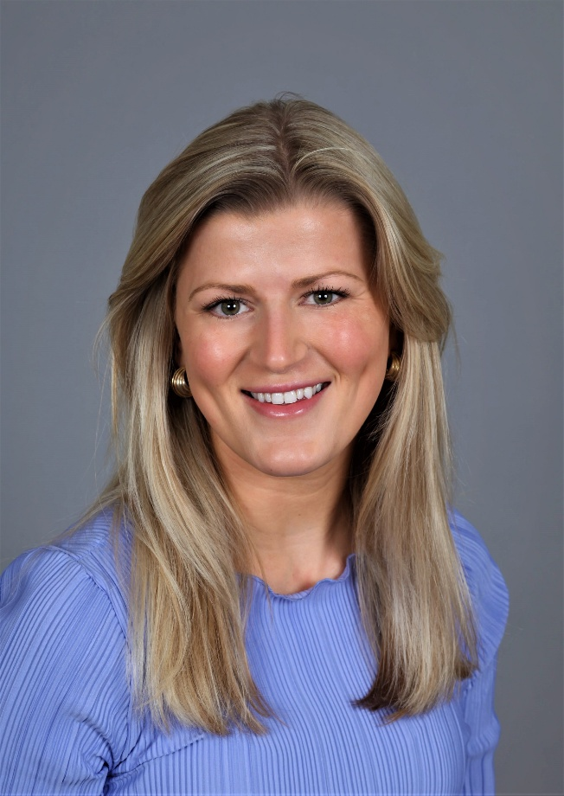
Session Title:
Presenter: Molly Gerards, Au.D.
Speaker Bio: Molly Gerads is the Phonak Clinical Trainer based out of Minneapolis, MN. She joined the Phonak team after practicing Audiology at a large health system in Minnesota. She received her Doctor of Audiology degree from Pacific University in Hillsboro, Oregon, and her Bachelor’s degree in Communication Science and Disorders from the University of Wisconsin - River Falls. Her clinical experience includes diagnostic audiology ranging from pediatrics to geriatrics as well as hearing aid and assistive listening device evaluation and fitting. As a Clinical Trainer with Phonak, Molly focuses on educating providers and supporting them in achieving successful outcomes for both their practices and their patients.
Learning Objectives: Upon completion of this course, participants will be able to:

